**Standard Operating Procedure**

**Bush fitting and Removal**



**ODISHA MINING CORPORATION LTD.**

**KODINGAMALI BAUXITE MINE**

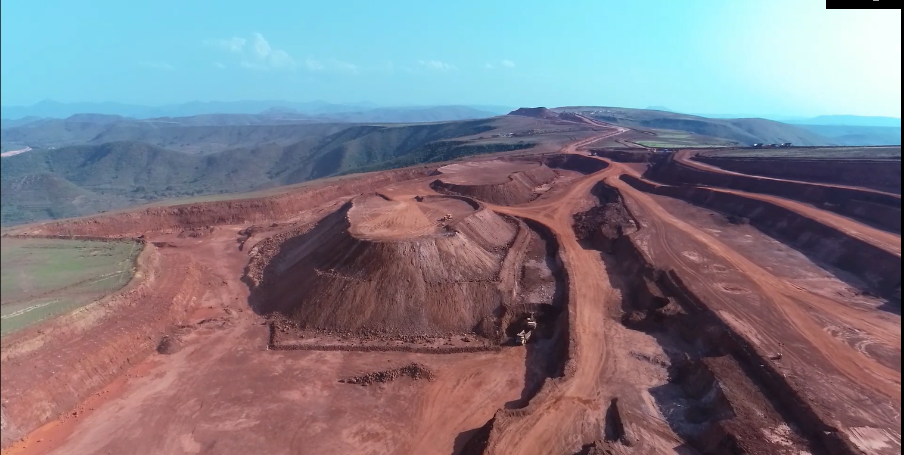

**Authorized By**

1. Only qualified and authorized persons are allowed for the work.
2. Ensure that equipment’s/tools for certain task are of proper condition and as per the requirement.
3. Clean properly the area of bushing to be removed.

**Procedure for Bush Fitting and removing for different size, type and condition**

**Plain and Parallel type bush with free access to both ends**

1. A strong piece of tubing into which the bush will stride and slightly longer than the bush is required.
2. A stiff collar is needed to bridge the end of the tubing. Another collar slightly smaller than the outside of the bush to bear on the end & a bolt threaded about half its length to pass through all.

**Bush fitted on Blind holes**

1. If the surrounding metal of blind bush is aluminum then it can be expanded by heating and for a steel bush it may drop out if the component is tapped sharply on a block of wood.
2. The heating may be carried out in hot water or oil or carefully in the flame of a blowlamp.

**Flange Type bush**

1. It will most likely not be fitted right to the end of its bore; and in the absence of oil grooves it can be removed “hydraulically.
2. In case of a drilled holes are permissible in a bush housing a punch can be used for removal and the holes fitted with grub screws.

**Force-Fit Bush**

1. Material the same as the bush is roughly shaped to its bore radius and wedged in with packing. Then a drill can be run down to cut away the wall and reduce the grip.
2. With the packing pulled out with pliers, the bush can be drawn with its top burred over a collar on a bolt.
3. Given clearance behind a bush, removal can be effected by entering a slotted plate on a bolt.
4. A sleeve cut at an angle aiding in entering the plate. It is then withdrawn from the bolt for a tube, bridge-piece and nut to be fitted.